Business case

Project II - Analysis and development project

Caspar, David, Frédéric, Stef & Lenn

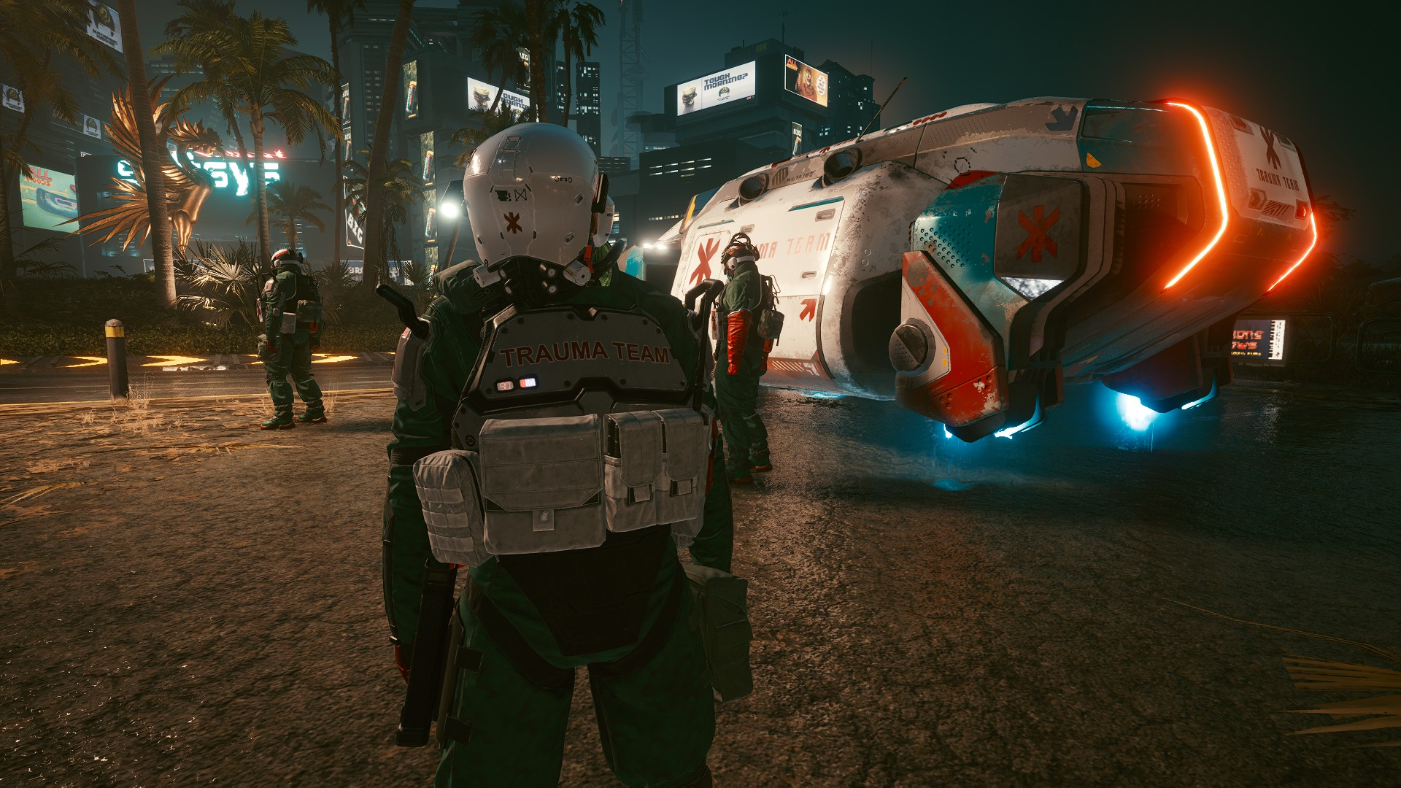

# Basic concept and approach (mission & vision)

**1.1 Basic concept and approach**

The potentially hazardous environment of business operations in a dark dystopian Mars, and The Mars Corporate War established there means that emergency management and response planning are critical to the health and safety of the workers of any company. So that’s where our service comes into place. We will provide a service to help people in critical situations with any medical needs.

A client's health is monitored by a device we put on them, and if a client takes a turn for the worse, an aerial vehicle squad receives their GPS signal and arrives on the scene in minutes. Reaction time and additional perks are dependent on the client's insurance package.

We were inspired by the game Cyberpunk 2077. The setting of this ‘triple A’ game is similar to ours. It also takes place in a dystopian world, where there is an ongoing corporation war. Where people get extracted in critical situations by an AV (Aerial Vehicle). Our personnel are also military equipped and will shoot if a violent conflict happens. We like this concept so we decided to base our service on this.

**1.2 Mission and vision**

We are M.A.R.S. (Mars Active Response System). Our domain is based on IoT and Industrial Security solutions. We provide 24/7 emergency aerial vehicle dispatch with a reflex always-ready pilot, armed safety experts, and military-trained paramedics.

This is our vision of Mars, with all the current domes as of starting our company. This has room for expansion if needed.

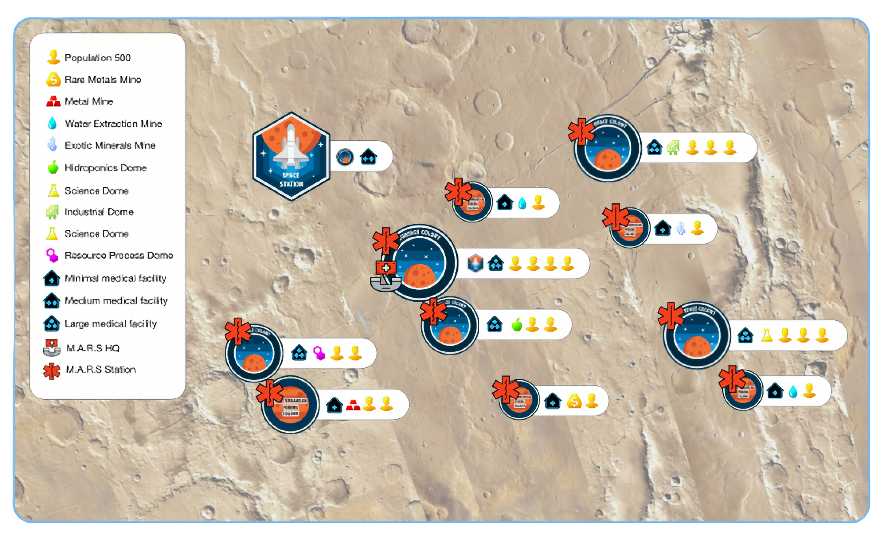

# Requirements

## 2.1 Functional Requirements

* Marketing campaign: Marketing and Advertising from when a possible clients comes from earth to Mars. If the client doesn’t buy our service, we’ll use targeted ads and fomo-strategies to win more clients.
* Payment system: A fast and reliable way (blockchain-based) way to receive fundings from our clients so we can save them.
* Monitoring vitals of clients: Our clients will be monitored using a implanted bio-chip. These will be outsourced by another company on Mars, and we will use their secure API to monitor our clients at all times.
* Locating and navigation system: Our headquarters have staff to guide our field teams to critical clients and automatically direct them to the nearest hospital.
* Medical and military equipment: Our field team will extract our clients with an aerial vehicle. In case our client is heavily wounded or needs heavy stabilisation, we’ll put them in a cryogenic tank to stop any further bleeding.
* Landing or delivery area: Once we have collected our client, our field team will deliver them to the nearest hospital. We will have a dedicated landing area because we work closely together with the hospitals.

## 2.2 Non-Functional Requirements

* Mobile, portable and easy to distribute marketing campaign
  + Greater reach
* Secure, fast & cheap payment system
  + Cheap (no big fees for payment processing)
* Accurate, fast monitoring system
  + Avoid unnecessary deployments
  + Avoid arriving too late
* Optimized navigation system, reliable navigation system
  + Shortest, fastest routes to arrive in time
* High quality, reliable medical and military equipment
  + High quality: it is not allowed to fail during an operation
  + reliable: have fallbacks, e.g.: power loss
* Easy to access landing area
  + Allow for fast and seamless delivery and departure to the hospital without delays

## 

# Marketing & sales

## 3.1 Product

### Building and Control Centre

Where the actual monitoring and dispatching of recovery units are organized. Here there will be access to software and communications to easily and quickly deploy an active response team. Risk areas will be monitored and updated here in real-time. A high-risk area is an area where violence is likely. Extraction in a high-risk area is bound to be tricky and dangerous for both our field team and our equipment. A low-risk area is more likely to allow for a smooth and risk-free extraction.

### Ambulance and Extraction

Aerial vehicles with trained pilots and enough automation to reach the patients without the risk of crashing. A team that is capable of protecting, extracting and stabilizing the client in a fast and structured manner, even under pressure. Good coordination is a key feature to efficiently deliver a client to the hospital and warrant their chances of survival.

## 3.2 Price

### Subscriptions with tiers

#### *Why Subscriptions?*

A one-time payment would be way too expensive, and clients don’t always need lifetime protection. The ability to stop your subscription or extend it is allowing for a more flexible and financially maintainable way of ensuring your safety.

#### *Why Tiers?*

Not all clients will be exposed to the same level of risk. We offer tiers to allow clients to define their level of protection on a flexible and personal level. Upgrading or downgrading from or to another tier is possible.

A higher tier means a higher priority of extraction in case of multiple emergencies at the same time. We will use 3 kinds of tiers. That being: Silver, Gold, Platinum. The packages include different things, like the distance that we’ll travel, the amount of force we’ll use and the priority you get.

###### 

###### Silver

Most affordable insurance package, which only covers **evacuations from within domes**. Force will not be used to extract the client. This package is intended for common folks who do not expect to get into real tough trouble.

###### Gold

Premium insurance package, which covers **all silver-tier perks with an added 100 km radius outside the habitat of a dome** or industrial area, and priority extraction over silver clients in case of a queue. Limited use of force (less-than-lethal: tasers, rubber bullets, batons, flashbangs) to extract the client is included in this package.

This package is intended for people who have a realistic risk of a critical injury in either their job or low-level conflicts.

###### Platinum

Omni-insurance package. Platinum includes extraction on **any location of the planet** at any time, with the highest priority. All other perks of both Silver and Gold are included. Lethal force is used if required. Personalized perks are possible once discussed with the company.

## 3.3 Place

Our product will be first introduced to possible clients in the orbital station. There our sales-agent will try to sell our insurance to everyone who passes through the station to go to the surface. He will explain all the dangers over there and how our service protect them from these dangers.  
If a possible clients refuses our offer in the orbital station, they will receive ads on there phone, tablet and computer. These ads will try to convince them into buying our insurance. If they are convinced, they can just simply open our app and buy our service.

## 3.4 Promotion

Promotion will be primarily done in two ways.

Information about our services is delivered in the space station through digital billboards and our salesmen. This way, it will be an eyecatcher in the busy environment. The CEOs of companies on Mars are targeted this way as they are an effective way to get in contact with a company that might be interested in buying our products.

On the other hand, a more general public is targeted with ads on their devices if they didn’t buy our service. Our ads will be outsourced by “The Martian Sol”, a social hub service. There we buy ad space over the course of a year, every year.

## 3.5 USP

Our service is a one of a kind, since the only medical services are the hospitals themselves. There is no other service that comes to you and brings you to these hospitals. Depending of your package, we will even mountains* to save you. Saving you is mostly done automatically, since you will have an embedded bio-chip so we can monitor your vitals. Once your vitals go critical, we’ll send an ambulance to you. There is also always a manual way to call an ambulance.

*figuratively

# Human Resources

* CEO
* CFO
* Sales and marketing (sales officer) (marketing agents)
* Ambulance Teams (Pilot, security specialist, senior EMT, assistant EMT)
* Control centre operators
* Maintenance of assets (cars, buildings) is outsourced to reputable companies

## CEO

The CEO manages the supervision of all operations and communicates the wishes of investors and platinum clients. He dictates the strategies and policies to follow in the company to optimize the profitability of our services.

## CFO

The CFO manages all calculations related to payrolls, investments, accountability, purchasing of assets and paying maintenance companies.

## Sales and marketing

The sales and marketing mission is to promote our services to the maximum amount of the public and ensure high retention of current customers.

## Ambulance Teams

Professional ambulance staff is required for the performant execution of our project. Fast extraction and efficient protection of the client and the equipment is a vital aspect of our service.

## Control centre operators

The operators respond to calls and monitor vitals and location. They are the primary line of communication and information for our ambulance teams.

## 4.1 Growth

Our company will grow over time because more people will come to Mars and more people will be interested in our insurance. This means we’ll need more field and office teams, because they protect our clients. Our marketing will not change, since we run ads and that doesn’t require people to do. The people coming through the orbital station will still be small, since coming to Mars is very expensive so we don’t need to add more people there when the population grows.

# Strategic Partners

## Group 11: Life outside the dome - Suits and protection equipment

Suits and protective equipment will be provided by this group. The location could be accessed from the suit if the staff is wearing it.

## Group 12: MarSana - Lab-on-Chip implant for a real-life feed of health parameters.

This group will provide an API that our operators can use to analyse the vitals of our clients in real-time and give us a location feed for clients that are not wearing a suit.

## Group 14: Community hub - Meteorological information.

This group provides us with danger readings for zones we might have to travel through.

## Vehicle Maintenance (outsourced)

An already existing company is hired to take care of vehicle maintenance.

## Transportation of equipment from earth (outsourced)

This group will provide any medical or military resource needs. Also other goods like IT devices for example.

## Cargo tunnel access to the mining area (partner)

We need access to tunnels to extract a patient from underground to the surface.

## Hospitals to accept clients (partner)

We’ll work together with the hospitals from Mars, since we are just first aid. For actual treatment, we’ll have to drop our clients off at the hospital.

# 

# Risk Management

## Control room failure

Redundancy of our systems. This should somewhat cover our operability in case of an electrical failure. This means that there are multiple backup systems so that our operators can keep working in all circumstances.

## Meteorological risks

Our Ambulance teams can be faced with extreme dangers like storms or space-dust rain. We will use danger alerts from group 14s API. Our pathing will update the GPS of the aerial vehicles so they don’t go through dangerous areas on purpose. This changes if our client is caught in one of these storms, then we have to go through one. Besides these special cases, we will always avoid storms and other meteorological risks.

## Lack of capacity

In case of many simultaneous evacuation requests from the same location, with only one manned AV, we will send the manned AV plus all available AVs in automatic navigation mode. The teams will evacuate each patient to one of the automatic AVs. This is comparable to “Teslas” from the earth, in that they will go to the location of our clients all by themselves so we don’t need a team in them.

The order of evacuation is defined by the tiers of the clients.

## Failure of a vehicle

A vehicle could be blown up or receive an overwhelming amount of force once arrived on location. Based on the package of the client, the team will either postpone the extraction, reply with various levels of force or send more manned units.

If the client is subscribed to us with the silver tier, we will postpone the extraction until the zone is safer to operate in.

The other packages will use a (limited)* amount of force to extract the client if needed.

## 6.1 Data breach protocol

In case of a data breach in our company, we’ll first investigate what data has been breached. We use other companies their data as well, and if that is leaked we’ll let them handle that because that is something out of our control.

If a data breach happens at our part of the company, we’ll notify our clients what data of theirs could possibly at risk. If we know what data has been breached for certain we’ll tell our clients what steps to take to secure their data again.

*Limited amount of force included in the gold package is explained in our tiers mentioned above in 3.2 Price.

# Financial Calculations

## 7.1 Revenue

### 7.1.1 Price

Our insurance service will have a monthly and yearly plan. We chose to opt for this strategy because some people don’t need a yearly plan if they only stay for 2 months. We also opted for 3 plans, depending on the amount of insurance and protection you’ll need.

Our entry-level plan is called “**silver**” and is **500 MarsCoin** per **month**. This includes getting our clients inside of the domes without any use of force.

Our second plan, for the dare-devils and mine workers, will be called “**gold**”. This plan is a bit more expensive since our radius for picking up clients is bigger and a minimal amount of force could be used. To compensate for fuel and the equipment used, this plan will be priced at **750 MarsCoin** per **month**.

Our last plan is called “**platinum**” and is focused on high-profile clients. There is no maximum limit on the distance we’ll travel to extract these clients. These clients have the highest priority over all other tiers. There is also no limit to the amount of force used. Because of this, our price is higher than all other tiers we offer. This tier is aimed at for example CEOs of big companies and comes down to **1000** **MarsCoin** per **month**.

### 7.1.2 Quantity per period

There are 1000 people in a single dome. The people that work in the mines are also included in this number. This means that a dome with a lot of miners will seem a bit more empty, but that’s because they are in the mines. The families of the miners will stay in the domes.

We assume that 9 out of 10 people will need and buy our insurance. This boils down to **9000** subscriptions every month.

Of these 9000 people, **50%** of them will only need the **silver** package. These people will stay in their domes and won’t need the possible force or extra travel costs.

**45%** of the population will need the **gold** package. This means the people will do small amounts of travel beyond their domes or will be in a zone where small amounts of force will have to be used.

Only **5%** of the people on Mars will need the **platinum** package. These clients are CEOs or other high functions. They will need extractions from everywhere on the planet and will be rescued with, if needed, a high level of force.

In short, this means that 4500 silver packages, 4050 gold packages and 450 platinum packages will be sold every month.

## 7.2 Costs

### 7.2.1 Fixed costs

Since we need a **headquarter** to monitor our clients, the equivalent of a 911 dispatch office in America on earth. This will cost us a lot of money to buy, so we’ll opt to rent it. The rent comes down to **10’000 MarsCoin every year**. Because we rent the building, maintenance is included like cleaning.

Besides the headquarters, we need a **base station in every dome** to settle our field team and aerial vehicles. These will come down to **1000 MarsCoin every month**. This price includes cleaning and maintenance.

The **loans of our soldiers** are also a fixed cost. Since our soldiers had a high amount of training and are putting themselves at risk, we’ll pay them **1000 MarsCoin every month**.

Our **dispatchers** will have a more **office-oriented job**, so their payment won't be as high as the field teams. Their loan will be **500 MarsCoin** every month.

Our **salesmen** will need a **place to stay** in the **orbital station** while he waits for people to come in there to go to Mars. They will offer our possible clients our service so they have to be rested out before talking to them. The place to rest there and the fact that we can advertise there will cost us **1000 MarsCoin every year**.

Speaking of advertising, we will buy **ad space** from “The Martian Sol” to nudge users that might need an upgrade in a package and to target those who haven’t signed up yet. Their service comes down to **12024 MarsCoin every year**.

Since we’ll rescue people from the mines **underground**, we’ll need to lease an **office** there as well. There, we can use their cargo elevator to rescue a client to the surface and then to a hospital. This elevator is used less than a normal elevator and will extract our clients much faster than a normal elevator. The cost of the elevator will be included in the lease of the office down there. This office will come down to **500 MarsCoin per month**. The price is cheaper than the bigger office because we help the workers down there. This price also includes cleaning and maintenance in the building.

To extract a heavily injured client, we’ll use a **cryogenic tank**. These stabilize our clients and will make sure that they don’t bleed out. We’ll have one of these in every aerial vehicle. These will be leased from the hospitals and will come in around **500 MarsCoin** every month.   
Speaking of our **aerial vehicles**, the cost to lease an ambulance will be around **750 MarsCoin** a month for every ambulance. The price includes cleaning and fixing the ambulance every week. This means it will be sort of a “trade-in”-system, we give them the aerial vehicle of last week and they give us a “new” one while they fix the old one.

To protect our field team in the combat zone, we’ll need **bulletproof and medical suits**. These suits will be a modified version of another company on Mars to fit our needs. The lease of the suits will cost about **100 MarsCoin** a piece and are self-repairing. The **modifications** done to the suits are **50 MarsCoins extra** on top of the 100 MarsCoin mentioned above.

### 7.2.2 Variable costs

One of our variable costs is **fuel** for our aerial vehicles. This depends on the distance of our flight to get our client. This expense is combated by our tiers since the farther you go from the domes, the higher your tier should be. The higher the tier, the more the client has to pay. The cost per kilometre is relatively cheap, going by **0,05 MarsCoin/kilometre**.

Our second variable cost is our military equipment, like bullets, flashbangs… Those cost money if we have to use them in combat. This is again combated by our tiers since the cheapest option doesn’t include any form of force. The more a client pays, the more expensive gear we’ll use. The **cheap equipment** used to extract someone from the gold tier is around **50 MarsCoin** if thoroughly used. The more **expensive equipment** used to extract someone from the platinum package is around **100 MarsCoin** if everything has been used.

Giving our clients the biosensor is done by a company already on Mars. The **biosensor** cost and the cost to attach them to a client will be **200 MarsCoin**. Once attached, they pop up in our system and we can monitor them.

## 7.3 Break-even analysis

[Business Case](https://docs.google.com/spreadsheets/d/1CxYxmQbKDkbnE026-2ZkwwYEJtXUD1x77P_ddKpZ59I/edit#gid=0&range=A1:J17)

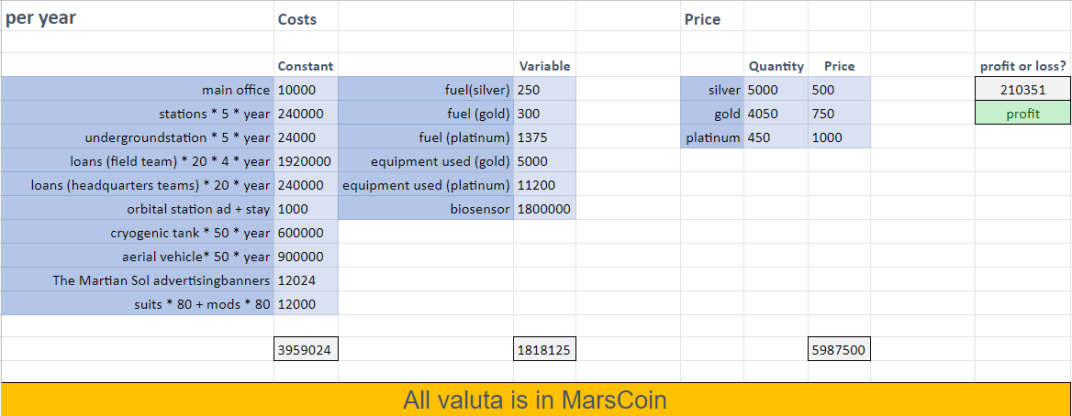

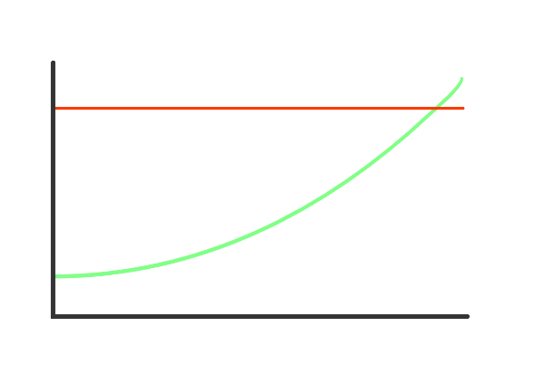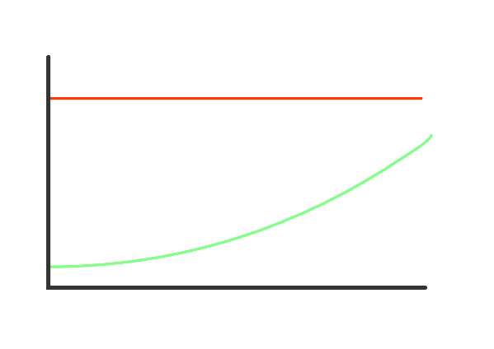With our 9000 clients, we have 210351 MarsCoin profit over a Martian year. This means in our first year in earth time, we will have some loss. Our first Martian year, we’ll have profit as shown in these heavily simplified graphs. The first one is to shows that in an earth year, we will almost be break even. The latter shows the same for a Martian year, and this shows us we will even have profit in our first year. The red line are our costs, the green one is price*quanity.

EARTH YEAR MARS YEAR

## 7.4 Finance mix

Our company has an annual profit rate of **210351 MarsCoin every year.** This number is based on if 9 out of every 10 people signs up for our insurance. This is a realistic number since Mars will be a very dangerous place to be since there is no government. If more people sign up for our insurance, we’ll have a higher profit rate. This is a realistic statement since people who don’t have our insurance will see how good it works.

Half of our clients are silver members, we can assume some of them will need an upgrade later if they notice they have to go away further than the domes allow. Another reason to upgrade is if they find themselves in conflict more often. Our gold and platinum package includes certain amounts of force, based on the package chosen.

We will buy ad space from “The Martian Sol” to nudge users that might need an upgrade in a package and to target those who haven’t signed up yet.

To start our company, we will need **5.777.149** MarsCoin to rescue our planned goal of 9000 people every year. Once we gathered this investment from **external sources and investors** we are set for 1 year. Since 9000 people every year and more on the horizon is a feasible number, we are sure to have every cost covered for the years to come. This means once year 1 has passed for our company, we can start to return to our investors without them needing to put extra money in our company.

MarsCoin has a pretty easy conversion rate for the people on earth. 1 MarsCoin is 1 euro and is a digital, blockchain-based coin. There is no physical version of it, so it has to be traded from the euro to MarsCoin.